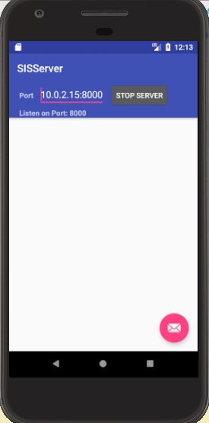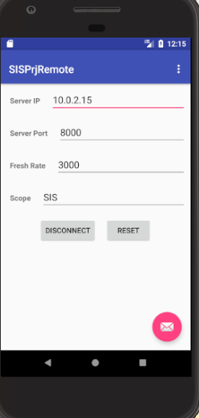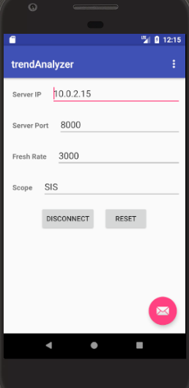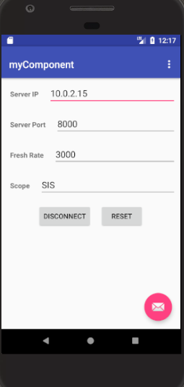

First each component needs to connect to the server. “Prjremote” is the admin that controls the opening of voting pools.

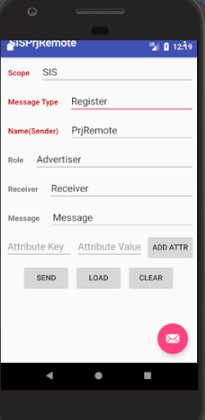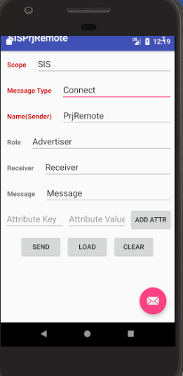

And then each component registers and connects to the Server so that it can communicate with the server.

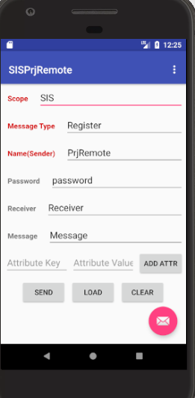

Enter the password to open/close the voting pool.

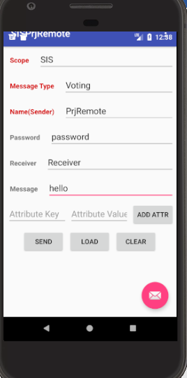

Enter the subject in “ Message “, “hello” for example, before opening the pool.

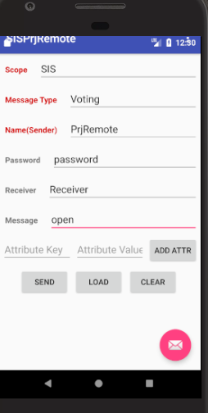

Enter “open” in message to control “open” voting pool.

And user can begin voting with a single number, “2” for example, representing the ID of candidates.

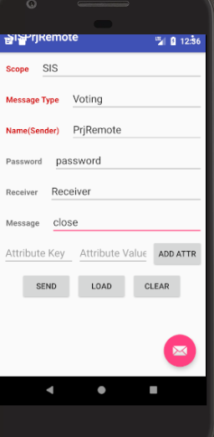

admin closes the pool.

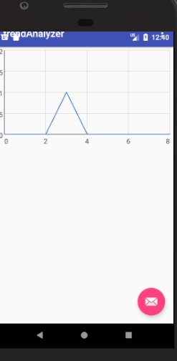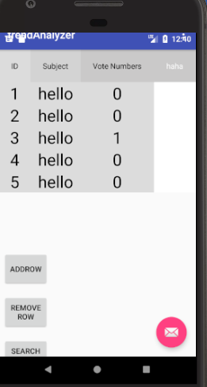

Trend analyzer will give you a table that records the history of voting in different subjects, and give a histogram that will predict the voting in a specific subject.

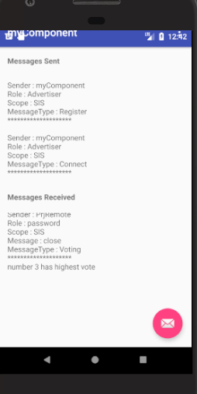

“MyComponent” will show us who wins the vote.